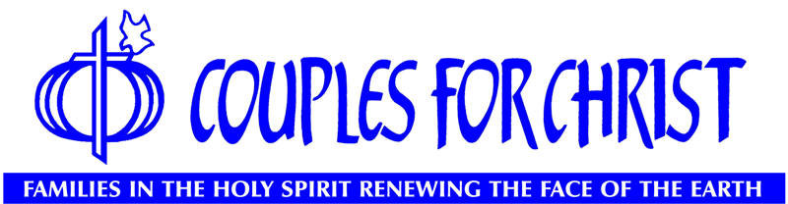

Couples for Christ (CFC) is a Catholic movement intended for the renewal and strengthening of Christian family life.

CFC’s family ministry, the Handmaids of the Lord (HOLD), set aside a time for the women of the ministry to discover more clearly and intimately God’s plan to them last September 21-22, 2019 at the Holy Family Catholic Church in Honolulu, through the Handmaids Enrichment Retreat I (HER I). This is in response to the need for their better understanding and appreciation of God’s plan in whatever their circumstance.

For each woman in CFC to discover more clearly and intimately God’s plan, this retreat evolved and is now made part of the HOLD pastoral formation. During the retreat, each participant spent time in an atmosphere where God’s Word was studied, understood and meditated on; where each person had the opportunity coming before the Lord and presented herself as a living oblation. Each person took stock and assessed herself, identified areas she needs to have specific improvements and/or change. Lastly, the retreat propelled the Handmaid to establish specific action plans which translate in concrete terms the changes/improvements she needs to work on after the retreat to truly live God’s call to the full.

The elements of the retreat were prayer, teachings, discussion starters, action planning, fellowship and Eucharistic celebration. The Handmaids Enrichment Retreat I was structured in such a way that the participants listened to practical talks from other women and discussed the talk as it applied to them as individuals. Sharing was emphasized to encourage/facilitate openness, honesty, sincerity among sisters. The retreat was climaxed by an action-planning individually which they will pursue after the retreat.

If you would like to know more about Couples for Christ (CFC) and its Family ministries, please email the following:

CFC Kids
Allen and Jackie Gervacio: allen.gervacio@gmail.com & jrcacal@yahoo.com

CFC Youth
Eddie and Maila Crisostomo: cfcy808@gmail.com & mailarose808@gmail.com
Randy and Mona Ishihara: g35ishihara@gmail.com & monahildaragodos@aol.com

Singles for Christ
Mark and Maricel Sebastian: almazora2110@yahoo.com & Sebastian.MariaCecilia@gmail.com

Handmaids of the Lord, Servants of the Lord and Couples for Christ
Rico & Vinya Manianglung: ricvin.cfchi@gmail.com
Ronnie & Mae Carag: rmjm51@yahoo.com

